Hand loading the Great 8x 68S
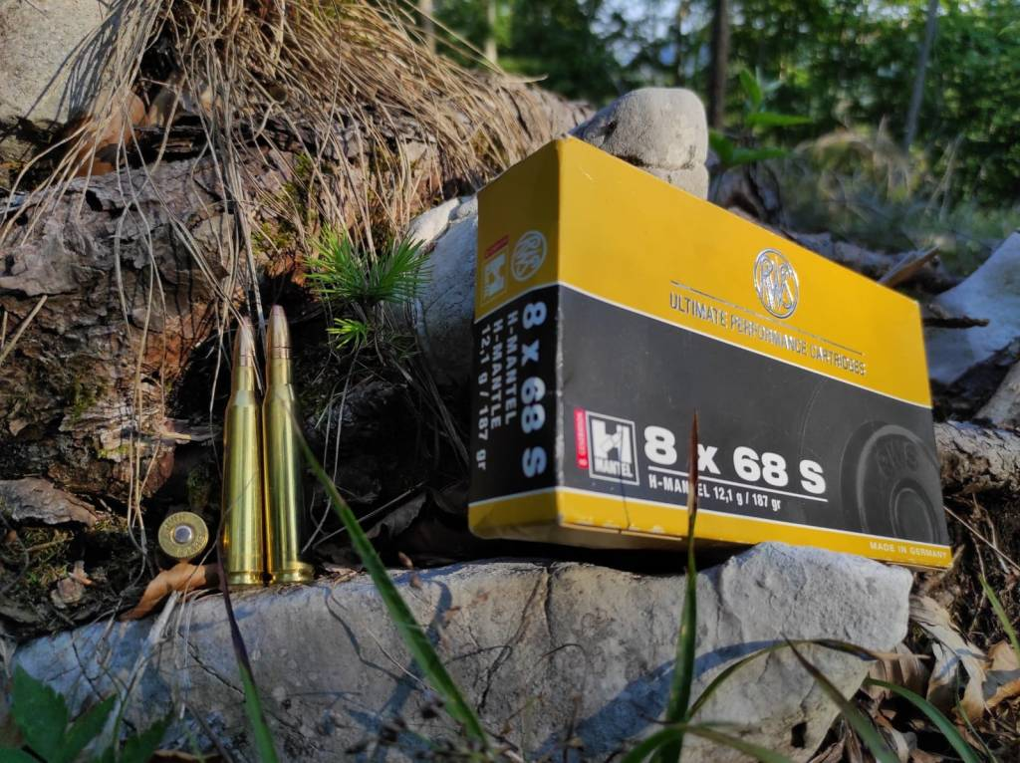
If you belong to the large heard of modern calibers enthusiasts, with their slender, long as a pencil bullets, this blog will make you feel uncomfortable.
The caliber we are talking about is an old Teutonic glory, which has survived a world war unscathed, and is gloriously moving towards a century of life, still counting on a large and solid plethora of faithful followers.
Born from August Schüler's visionary genius, it remained enveloped in a mysterious and dark aura for decades.
It has never been, and never will be, a mass product for any kind of hunter. It has never crossed European borders, with the only exception of African plains, and it certainly is not an all-round caliber.
It's rather intended for romantic hunters, the few remaining, able to appreciate its remarkable qualities.
Cost Management first: weapons chambering the faithfull 8x68S are all of excellent workmanship, heavy weight and value what they are worth. If you are lucky and tenacious, you could occasionally find a beautiful Europa 66, or a Sauer 80, or a Steyr. Rarely real jewels pop out from collections of elderly gourmets, as happened to me years ago.
Being valuable and very expensive weapons at the time, not infrequently have spent entire decades in a blind, with short hunting digressions in protected environments. Keep in mind that in the 70s these jewels cost as a small car, and were the top of European production.
Often they are almost brand new after half a century, seen the vigorous and punitive recoil: certainly uncomfortable for long sessions at shooting range, surely not a plinking tool.
Yep … the recoil … weight and running costs aside, the real monster to tame to dominate the old 8 is its vigorous recoil.
Nothing terrible or disabling, but many have been frightened and discouraged by this aspect. As always, good training at shooting range and excellent harmony with the gun are the key to successful hunting. So, once again, if you are looking for a caliber to shot 4 times per year, I recommend choosing another one.
Otherwise, if you are interested in a damn effective caliber on medium and large game, and you are willing to understand its philosophy, the dear 8x68S will become your faithful companion for the most beautiful and demanding forms of hunting.
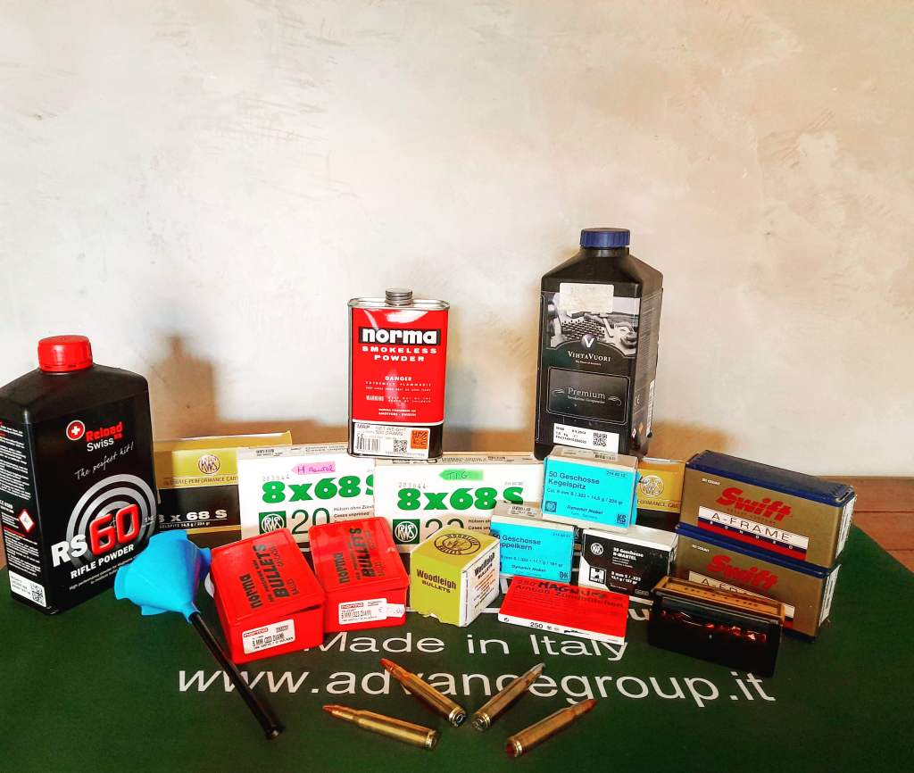Anything you ever wanted to know about 8x68S but you were afraid to ask..
Let's start by analyzing the case: it shows all its age, bottleneck is characteristic and fully responsible for strong and clear recoil. Walls are incredibly thick (try to see) but it's still roomy enough to contain voluminous slow burning powders, necessary to toss heavy 8 mm bullets.
Right now, only RWS, Brenneke and Norma produce 8x68S cartridges, while cases are also available from other Teutonic manufacturers (Horneber and SHM).
Today's availability of 8mm bullets can cover practically every hunting situation, from small roe deer to majestic red deer.
Virtually best bullets are those from 180 to 220 grains, with notable predilection for heavy bullets, with good exceptions conceived.
On light games, use of classic soft point bullets will achieve fast killing even at long range, while correct shot placement will avoid meat waste. On heavy games heavier bullets with progressive deformation will guarantee high energy transfer with exceptional penetration.
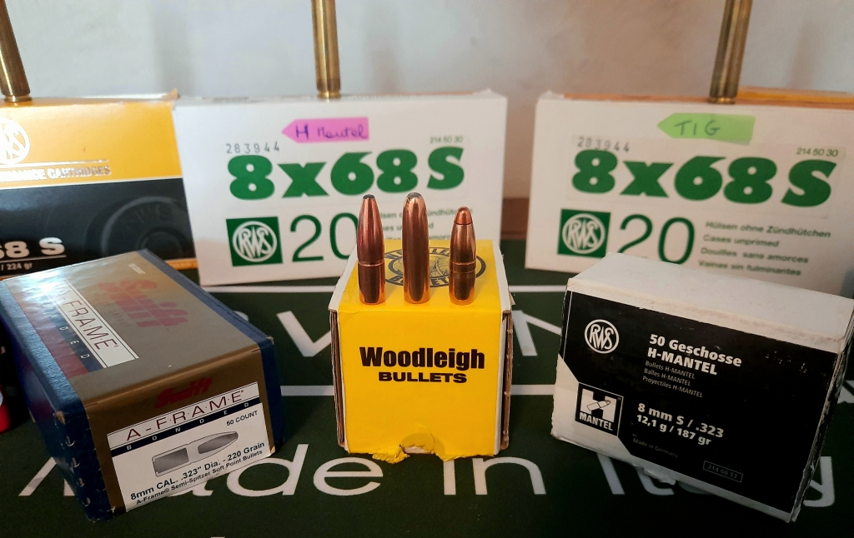Trinity
Modern bullets, such as Hornady SST or Nosler Accubond, with high ballistic coefficient and excellent terminal effects finally extend effective range of this old mighty powerhouse; others, such as the excellent 220 grain Sierra Gameking, allow extremely long shots, albeit with some limitations due to the frangible structure.
However, I'd love to point attention on a concept: this fine caliber was conceived with a different purpose than the long range shooting, so fashionable today; The main destination was, as many will know, hunting huge bull deer during the Rut. In Middle-European tradition, hunting during the “brunft” rose to the highest expression of hunting culture. Approaching a huge male intent on protecting his harem, following its struggling rut in the thick woods until it emerges from the autumn foliage in all its pride, ending the hunt with a single, decisive shot. The big 8 was and remains a brutal stopper, a devastating energy deliverer. Large deer hit in the shoulder usually collapse to the ground in a single instant, leaving no room for long escapes and chases.
It may seem like an unpleasant excess: in the .308 era, when a little cartridge is claimed enough for almost anything, it could seem so, but at a time, when forest's Lord dignity was held in high esteem, any hunter with a noble soul claimed to bring down the King with the right deference, since a monarch can be dismissed but not humiliated or offended in his dignity.
Different ages, different men.
Anyone who has hunted deer during the rut has indelible memories, the lucky ones who did with a good 8x68S rifle have goosebumps just remembering.
The power expressed, combined with flat trajectory, allow the hunter to trust the old 8 up to 300 meters without substantial corrections.
Zeroing the scope 6 centimeters above the mouth at 100 meters, bullet's drop is just a few centimeters from the center up to 300 meters, so you just forget compensations, calculations, ballistic turrets, just think about the hunt.
The secret of the 8 mm effectiveness must exquisitely be attributed to .323 bullets characteristics: forgetting for a while bullet's structure and material, two key parameters are ballistic coefficient and sectional density.
Sectional density of a typical 196 grain lead bullet stands at .268, with a usually modest ballistic coefficient, especially for today's standards.
Shortly, a low sectional density means high energy transfer and, if combined with heavy weight, sufficient penetration to reach vitals.
In the field we will witness lightning-fast killing, on large and light animals.
This rule has limitations, of course. Bullet's shape, structure and materials will surely influence this concept. So we can only apply by comparing similar ogives: a monolithic and a soft point will never have the same behavior.
Putting at work sectional density by carefully choosing the bullet is the key to adapt our weapon practically to any form of hunting.
On the other hand, almost all 8mm bullets have a rather low ballistic coefficient, determining rapid speed and energy loss, beyond 200 meters. There are commendable exceptions, such as the Sierra gameking or Woodleigh Protected Point, both 220 grains, with high BC and consistent weight, capable of delivering high energy well beyond 300 meters: two bad boys in open fields.
However, we would like to reiterate it, 8x68S is not a long-range cartridge.
Any hypertrophic 7mm or .300 on hydrage, with their long and tapered nose cones, will beat our granny over 200-250 meters. Take a look at ballistic tables, you will see how energy and speed values ​​strongly overcome our 8mm.
But below these distances, unless we decidedly shift to African calibers, few cartridges are able to compete: after all, we are dancing around 5600 joules, values ​​comfortably considered typical of Big Game Hunting.
Normally, as said words ago, weapons chambering the big 8x68S are of good or excellent workmanship, and often equipped with variable low magnification optics, perfect in low light conditions, like in woods, but really versatile even in open spaces.
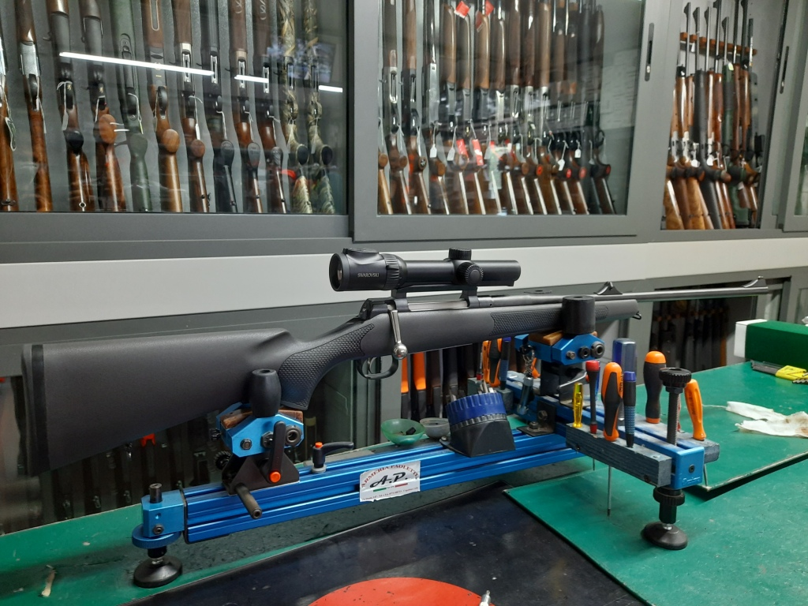Mounting a good Swarovski, Z8i 0.75-6×20
Personally, I find modern strike optics to be very effective: compact, lightweight, with an illuminated reticle and a comfortable focal distance, they proved to be extremely versatile both for hunting and stalking, even on drive hunt, shooting running wild boar.
Handloading is quite easy, and surely enhance peculiar qualities of the cartridge, adapting weapon/cartridge combination to hunter's needs. With some experience, it's possible to tailor-made loads with slightly reduced energies, or hot loads close to maximum values.
I recommend paying maniacal attention to the Case, usually RWS. All cases must be trimmed at the same length, while flaring the collar to facilitate bullet's insertion can help with bonded bullets. Caliber's typical pressures, usually well above 4000 bar, suggests to fully recalibrate the case, not just the collar: brass migration from the shoulder is substantial and limits case's life to a few cycles.
Best primers, over time, turned out to be the RWS, obviously Magnum: expensive but damn reliable and constant.
The use of a funnel with a long drop tube is desirable, especially with somewhat voluminous powders such as MRP or N160.
This simple accessory allows you to correctly settle powder, to uniformly exploit all the case volume.
Some loads may result zero-spaced, with bullets sitting on powder, or slightly compressed.
Due to previous experiences, I do not recommend compressed charges, especially in hot temperatures or after months from recharging.
Fundamental attention must be kept at free bore value for each bullet that you intend to use, as well as feeding fluidity; some ogives, inevitably, wan't be digested, others will be perfect and accurate.
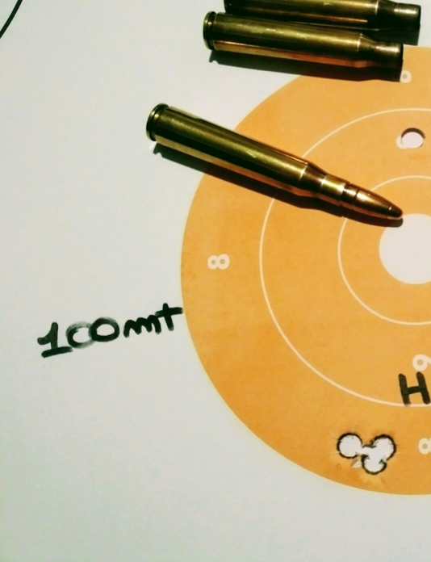H Mantel accuracy: superb.
When choosing bullet, always keep these aspects in mind, in order to avoid wasting hours of work and bad experiences on the field.
Finally the powders.
Over the years I have come to a conclusion, after tests, attempts and many headaches.
The two most versatile powders are Norma's MRP and Reload Swisse RS60; the first one is unbeatable with heavy bullets, the second incredibly versatile in an unspecified number of calibers: It always burns at 100%, leaves no residue and does not produce any muzzle flash.
Both powders are very stable in a wide range of temperatures and can easily manage 170 to 250 grains bullets: Really perfect.
The eternal N160 remains discreetly versatile, even if I don't find it constant as the temperature changes.
Lately I started using the Norma 203B, to get a good load with 196 grain Alaska bullet: precise, constant and with a smooth recoil. The energy expressed is on the edge of 500 kgm, limited detection and perfect burning. This cartridge should be great for hunting fallow deer’s and wild boars in woods, with excellent opportunities on drive hunt
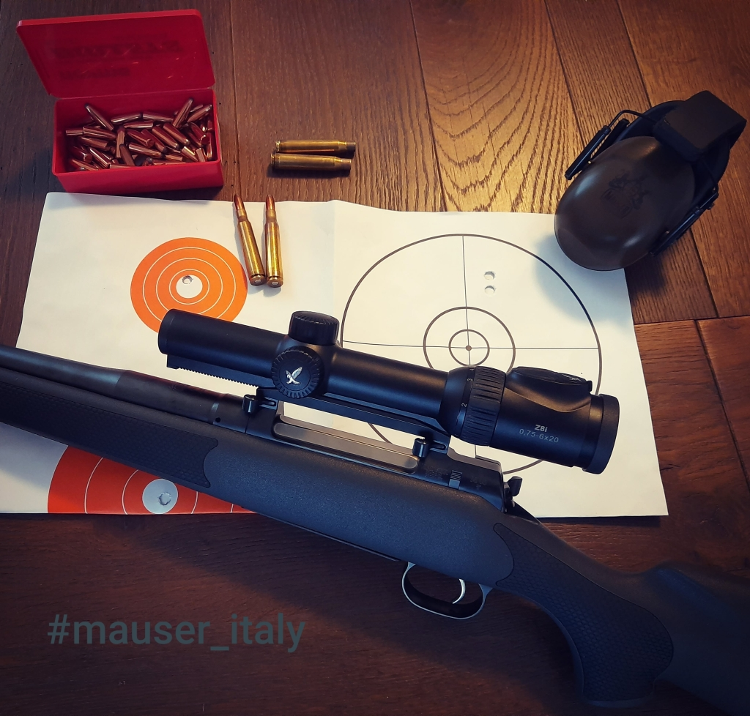Alaska bullets and M03
Over the years, as a true fanatic of the mighty 8×68S, I have assembled numerous cartridges, using many of the available bullets. Some have proven to be good, others only fair, few really superlative.
I tested my loads in two of the very best rifles ever made: the venerable Mauser Europa 66, and the excellent Mauser M03 Extreme. Accuracy is superimposable, recoil much more manageable with M03, thanks to superlative ergonomics and perfect stock design.
In both guns, one the technological evolution of the other, 65 cm barrel allows the cartridge to express itself to the maximum, without compromise.
As Handolading remains a potentially dangerous activity, it is not my intention to distribute recipes and doses, I strongly recommend to consult manuals, paper or digital ones, and strictly follow doses indicated. An excellent tool to understand and refine the art of handloading is Quick Load program: it requires patience and a little knowledge, but allows you to create almost perfect cartridges.
I will describe behavior and characteristics of bullets used over the years, instead.
• Swift A-Frame.
Definitely adequate. They are among few bullets not to fear sidereal speeds. A double bonded core that keeps the promise of retaining very high residual weight. Penetration is its mission, even through massive bones and very thick muscle masses. 200 grain bullets are absolutely perfect for all major European game, but they perform very well even on the light ones, with quick killing and remarkable meat respect. In spite of what many say, it's able to mushroom even at moderate speeds, guaranteeing effectiveness well beyond 200 meters: I have used it for several seasons in 8x57js, for close shots on medium games, always with outstanding kills. Loaded on our 8x68S it is more than surprising on large wild boars, deer, and fallow deer and certainly on larger animals such as bears and moose.
The 220-grainers are definitely intended for large and very large game. Full penetration is always achieved, even on gigantic animals: an exit hole and blood trail are guaranteed.
Perhaps too much for the old continent, but if a close encounter with an adult male deer weighing 200 kilograms is in the count, there is no better ally. Handling tremendous impacts at lightning-fast speeds is child's play for these stout ogives, the only double cores in the world capable of uniformly deforming both front and rear, generating large and frayed egress holes.
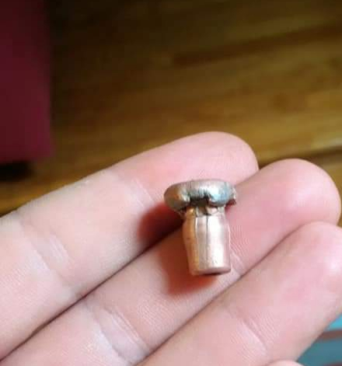200 grains A Frame through a wild boar.
The greatest difficulty is to convince them to produce tight shot patterns: being very tough bullets, with an extremely hard rear core, they produce much higher pressures than the others, perhaps even than monolithic ones. Old Europa 66 does not digest them easily. I managed to obtain discreet patterns, which can certainly be used for hunting especially, especially huge critters. The M03 proved to be much less choosy.
A-Frame have solid and unassailable reputation throughout Africa.
• H Mantle
My favorite, in some ways the perfect lover for our 8mm, certainly the one that most contributed to creating the legend.
The double core for excellence, the one from which many have drawn inspiration, shamelessly copied, without equaling fame and effectiveness. Also at first sight it's easy to understand what level of engineering and design are necessary to produce these nose cones: the front core is hollow, the rear one extremely hard and non-deformable.
The triumph of Teutonic metallurgical wisdom and Middle-European philosophy: when bonded bullets didn't exist neither in wetter dreams, a double core bullet was the best friend a hunter could ask for: the front core, upon impact, explodes dumping a lot of energy and seeding a myriad of secondary bullets; non-deformable rear core continues its run through bones, tissues, muscle masses, drilling an egress hole and a clearly visible blood trail, for delight of the faithful Bavarian hound. The maximum expression of Teutonic hunting doctrine: a single shot on the Blatt, a bullet designed to devastate the cardiopulmonary area, an exuberant caliber that ensures lightning-fast, clean killing.
As if that weren't enough, the eternal H Mantel has a decidedly singular weight, 187 grains, indecent precision and absolute constancy.
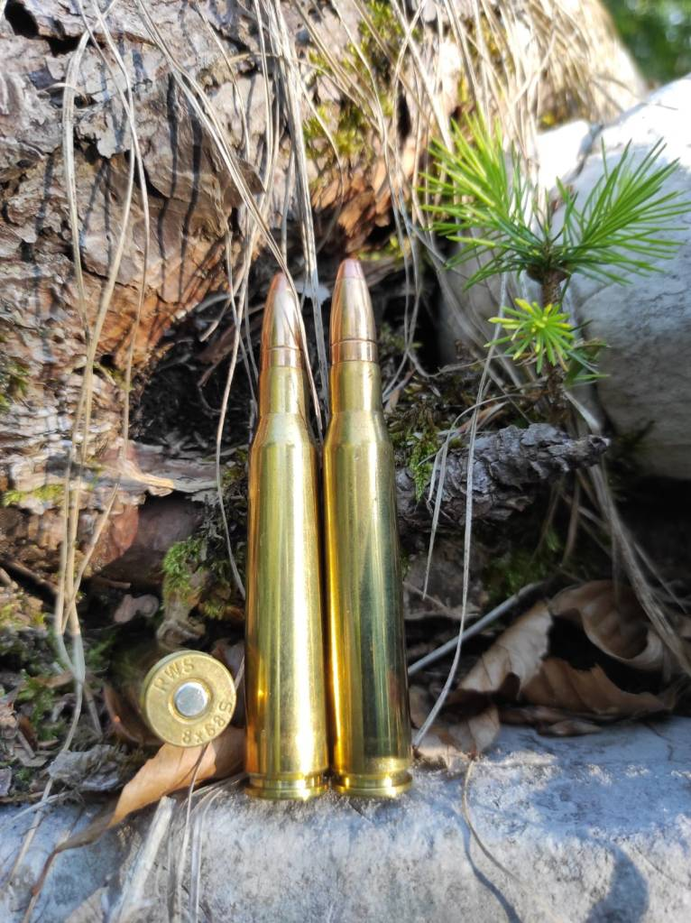
It is certainly the most precise and grazing ogive I have used. I tossed it through fallow deer, red deer, wild boar and sometimes even roe deer, always with the same exciting results. Long and very long shots are definitely the best terrain, while close shots can blow up the bullet, if aimed at big bones, even if it assures high stopping power even in extreme conditions.
Particular attention must be kept in dirty shots. Hitting vegetation can easily destroy the front core, greatly affecting its effectiveness.
Weidmannsheil!
Almost a century after its creation, the old H Mantel remains a reference standard, an excellent all-rounder: give extreme confidence.

• ID Classic .
A double core ogive with proven effectiveness, the design and construction are dated and today is plenty of better bullets. However, on light weight games it can be considered. The terminal ballistics is very similar to H Mantel's one, frangible front core and solid rear. I would not use them on games over 100-150 kg, especially if hoffed. Entry and exit holes are usually the same size, but internal wound is considerable, especially aiming at the boiling room.
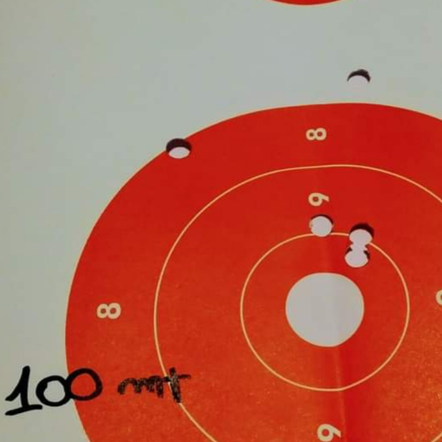ID Classic and N160
The blood on the anschutz is always evident, trail clearly visible, as long as it is used correctly.
The accuracy is very good, the weight, 198 grains, optimal
Both the N160 and the RS60 are perfect.
Brenneke produces a commercial cartridge topped with TIG bullet, identical in all to the ID Classic.

• Volcano Standard
One of the most versatile and effective bullets ever.
Norma had in catalog a cartridge loaded with Vulkan until recently, then inexplicably was dismissed. This bullet enjoys an excellent reputation among avid 8×68 users, while in other diameters it has often aroused problems and criticisms. In particular in 9.3mm and .30 caliber they are often accused of being explosive, causing horrible and superficial wounds without stopping the prey. Almost all these havoc occur in battle hunting, just because this bullet is not designed for snap shots at very short distances. When properly used, between 50 and 250 meters, Vulkan is capable of incredible knockdowns: relying on a high weight, 196 grains, we will witness a violent energy transfer, a penetration sufficient to reach the vitals even with angled shots on large beasts. The ballistic coefficient does not suggest long distances: I enjoyed top performance between 100 and 250 meters.
Good fallow deer, 180 meters.
The best powder among those tested was MRP, that tossed the Swedish bullet at 930 ms, with fine grouping and manageable recoil.
On light framed game, at medium distances, it doesn't cause meat damage as long as you avoid the shoulder.
• KEGELSPITZ RWS.
The Kegelspitz is always a good experience.
Not a coincidence that these beautiful ogives from RWS are among the most popular in Europe.
Thanks to their coat, the extended bearing surface, and core's goodness, they are accurate in almost all rifles and calibers, with surprising external ballistics in spite of the rather squat shape.
Over time, RWS has slightly reduced KS ogives speed in different calibers, and probably made them a little harder, so that today the typical disruptive effect of the old KS is obtainable only by handloading and pushing them hard. Basically, they are very good soft point bullets, with a quality coat and semi spitzer shape.
Not only high precision, they almost always produce terrible terminal effects. When launched at high speed, the expansion is extremely violent, with perflossal wounds and exit holes of impressive dimensions.
Up to now, only the 180 grain KS is still on business, good on light and medium game, not the same on very large animals.
Designed to release most of energy within the body, on large game it is not uncommon to fail to produce an exit hole, nevertheless it guarantees clean and rapid killing
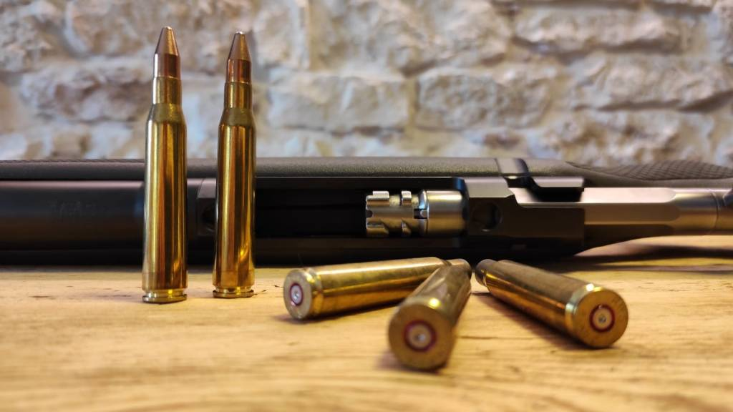Classic beauty.
Obviously, you cannot have everything: Kegelspitz ia all but a meat saver bullet. As a Tuscan proverb goes, where the bulet eats, then the hunter eats, if for any reason you need a bullet that forgives bad placement on dirty shots, or that anchors the prey in place even with necessarily not perfect shots, the old Kegelspitz is a faithful, very precise ally. Never underestimate this aspect, especially where wolf's packs are conspicuous. Many have had to look for roe deer or deer the day after, and they have found just the leftovers of a lavish banquet and nothing more; In these areas, any help is welcome, even sacrificing a few pounds of meat.
Until a few years ago, RWS produced what in my opinion, and others, was one of the very best producer on short and very short distance, the Kegelspitz in 224 grains.
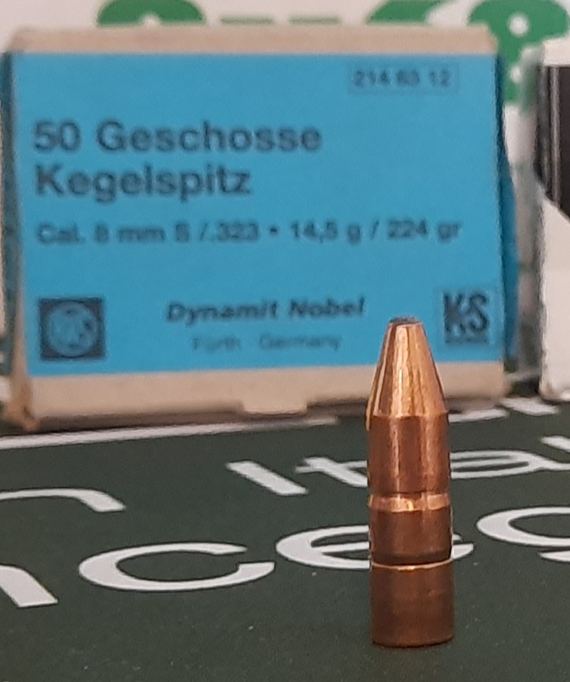Old but gold 224 KS.
An absolute champion, with an indecent stopping power, a real hammer, both for the prey and for the hunter. Being now out of business, we name it only out of nostalgia. I still have a box intact … some nice pencils.
• Spear Hot Core
There isn't much to write about.
They are cheap, high ballistic coefficient, get the job done very well. Like all Hot Core bullets, they are lightly bonded, the core is sealed to the shell, but not as tenaciously as in other bullets. Core separation is not uncommon, but being a 200 grain bullet, this does not affect its effectiveness. They are worth every penny of what they cost, I managed to get good shot groups with speeds close to 910 ms.
Different behavior has the 170 grain bullet of the same company; too fragile, they cause extensive damage unless used beyond 200 meters: I find them more suitable for the meek 8x57js.
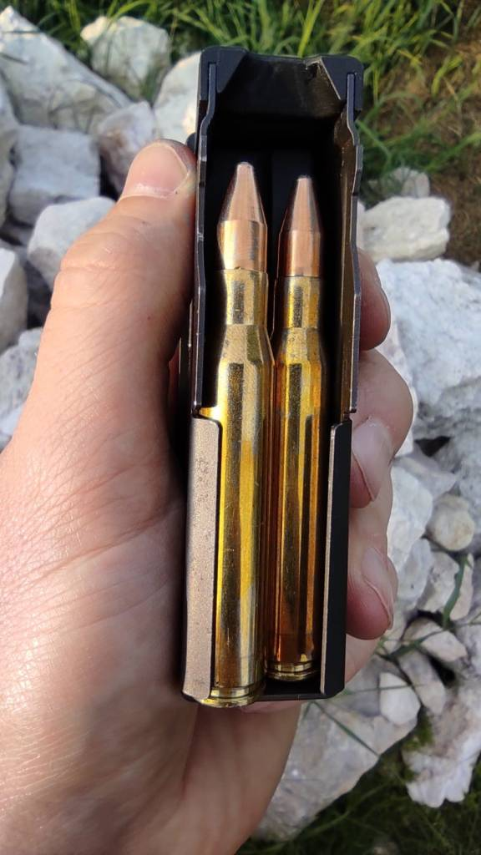
• Woodleigh Bullets .
The Woodies are wonderful.
In Africa they enjoy an unassailable reputation, also and above all for the results obtained in the dangerous game.
Few people know that Wodleigh invented the chemical bonding process. Their products are top quality, reliable and capable of incredible performance. In Italy and Europe they are not very widespread, thanks to the rather high cost and the low diffusion.
The 8mm bullet produced by this Australian company covers all the needs of the hunter, in every part of the globe.
The most suitable bullets are certainly Protected Point, available in 200 and 220 grains. The latter are equipped with one of the highest ballistic coefficients in the entire park available on the market.
These are hard bullets, famous for expanding evenly, favoring penetration over energy transfer. in African endless spaces, the plein game, they beat it on a par with the American cousins ​​A-Frame.
My favorite, among the great Aussies, is the 250-grain Soft Point Round Nose, a solid, pot-bellied pencil.
I bought them out of pure curiosity, in the first years, to feed the glory K98. I used them a few times for hunting, being literally speechless in the close-range typical of wild boar hunting. The curiosity about this bullet grew out of all proportion after writing a few emails to the manufacturer. I discovered that our 8x68S, strangely, enjoys a certain fame in the southern hemisphere. They gave me the information I wanted and I started working on a recipe. Years later, when I finally got a copy of their manual, I was surprised by the reveleance that had been devoted to this caliber and how much appreciation it enjoyed among aficionados of African soil.
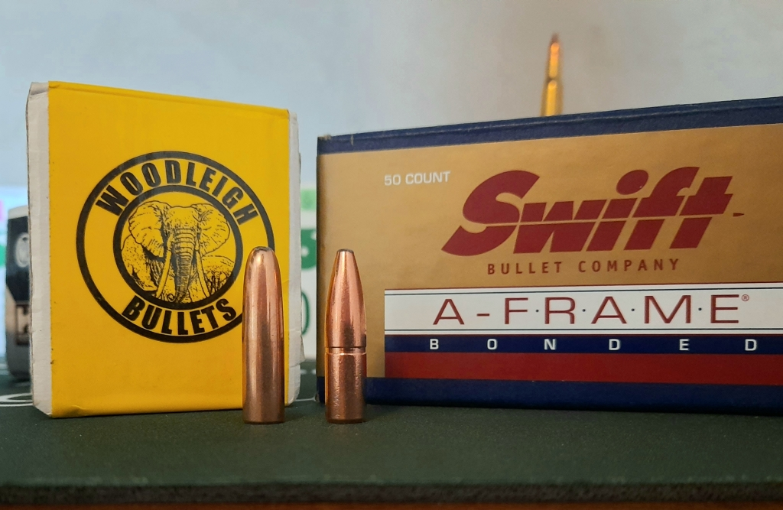Woodleigh 250 grains RNSP and 220 grains Swift A-Frame.
For Serious Hunting.
The heavy round noses are suitable for use between 2000 and 2700 feet seconds, ensuring excellent behavior within this range. The Great 8 is able to launch the long and plump 250-grain ball at 850 ms, and even with a rather arched trajectory, it's effective up to over 400 meters.
Using a ballistic turret, this bullet should be taken into utmost consideration for use on large and very large animals.
The extremely high mass contributes to maintaining adequate energy even at long distances, while the guarantee of mushroom information even at minimum residual speeds, assure complete penetration, in some time shocking. In medium-range shots, expansion and penetration have perfect balance, exceptional terminal ballistics especially if hitting large bones.
On close shots it is simply indecent: only 9.3 × 64 Brenneke can duplicate similar brutal knockdowns. You may not like it … but if territory is not your ally, it's often essential that game collapse on the spot.
In my opinion, the most suitable powder is MRP.
I recommend to carefully measure free bore for this bullet, and check the feeding from magazine, being the longest bullet on the market.
• Alaska Standard .
A good ball, a classic soft point in the most classic weight, 196 grains.
Reliable, precise, constant; For several years I used it with satisfaction in the two calibers it would be destined for, 8x57js and 8x57jrs.
Good stopping power, excellent penetration and high residual mass.
There are many more “appropriate” items for the superb 8 × 68, but even this remarkable super classic can be used with satisfaction.
Using a slightly faster powder than the classic MRP and N160, precision can be achieved at slightly milder speeds. Reducing speed, even maintaining optimal pressure regimes, guarantee full advantage from Alaska's stopping power avoiding separation between core and shell, overexpansion and fragmentation.
And more, using for example the Norma 203B, we'll achieve complete powder burning, limited deflection and no muzzle flashes, a very appreciable detail after sunset. The use at short distances is anything but difficult, expanding the range of possibilities for hunting in very dense woods and for drive hunts.
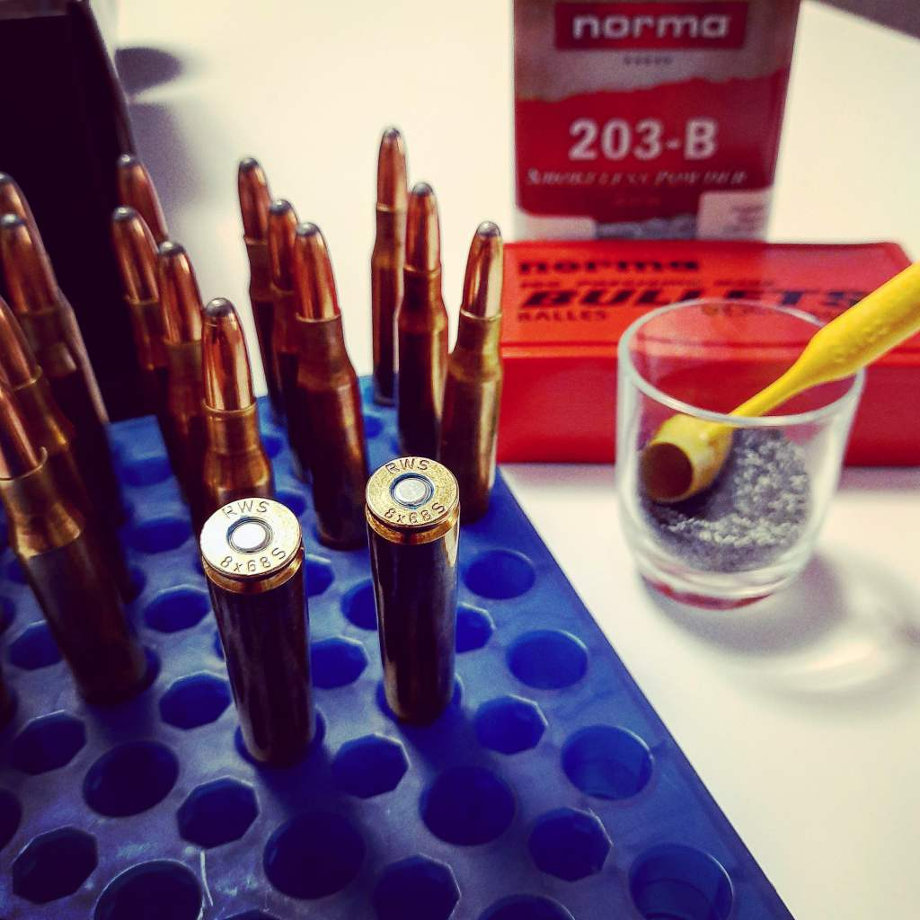Ready for the season.
This concludes our digression on 8x68S cartridge, one of the most incredible ballistic systems ever.
There are many ogives to test: the promising Hornady SST, the modern FOX monolithic, the proudly Italian Hasler, and others. We will try in the future.
Follow our Instagram:
https://instagram.com/mauser_italy?igshid=mxo6met723jx
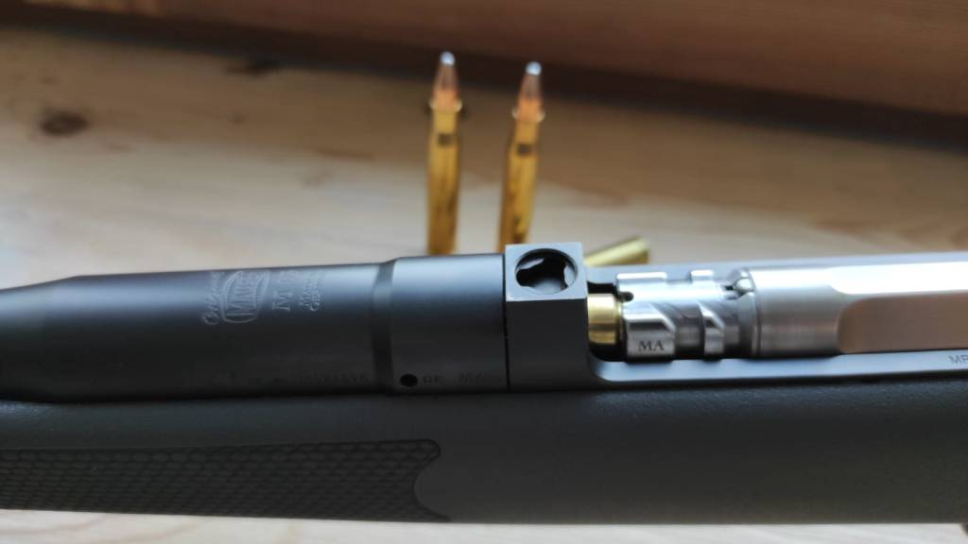That's all folks…

